中国科学技术大学计算机学院

计算机网络实验报告

实验二
利用Wireshark观察http报文

学 号：JL19110004
姓 名：徐语林
专 业：计算机科学与技术
指导老师：张信明

中国科学技术大学计算机学院
2020 年 10 月 25 日

一、 实验目的
1、 熟悉并掌握wireshark网络分析工具；
2、 捕获观察并分析HTTP报文结构；
二、 实验原理
Wireshark是一种非常流行的网络封包分析软件，功能十分强大。可以截取各种网络封包，显示网络封包的各种详细信息。Wireshark使用Npcap作为接口，直接与网卡进行数据报文交换，监听共享网络上传送的数据包

三、 实验条件
1、 硬件条件：一台PC机
2、 软件条件：win10, wireshark软件

四、 实验过程
1、 wireshark 的安装
按照助教给定的网址https://www.wireshark.org/#download
根据自己的环境选择wireshark下载，如下图
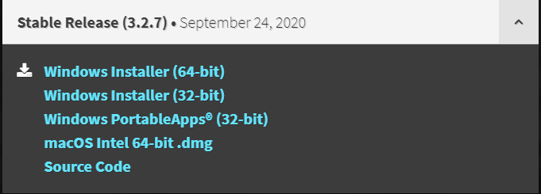

2、 利用wireshark来观察报文
（1）The Basic HTTP GET/response interaction
先打开chrome浏览器，将里面的缓存清空；再打开wireshark；开始捕获的时候设置过滤为“http”；打开第一个网址：
http://gaia.cs.umass.edu/wireshark-labs/HTTP-wireshark-file1.html；
稍等一小会儿停止捕获，得下图报文：
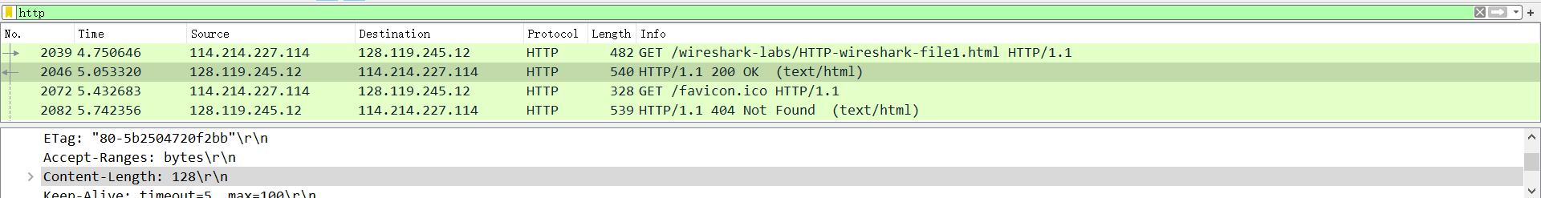
（2）The HTTP CONDITIONAL GET/response interaction
首先清空缓存，重新打开wireshark进行报文的捕获，打开第二个网页：
http://gaia.cs.umass.edu/wireshark-labs/HTTP-wireshark-file2.html
然后快速进行一次刷新，停止捕获，如下图：

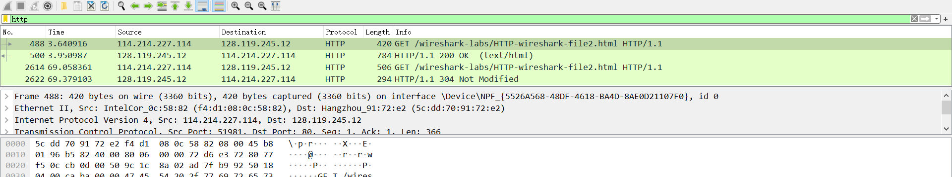
（3）Retrieving Long Documents
清空浏览器缓存，打开wireshark开始捕获，并打开第三个网页：
http://gaia.cs.umass.edu/wireshark-labs/HTTP-wireshark-file3.html
稍等一小会儿停止捕获，得到如下图报文：
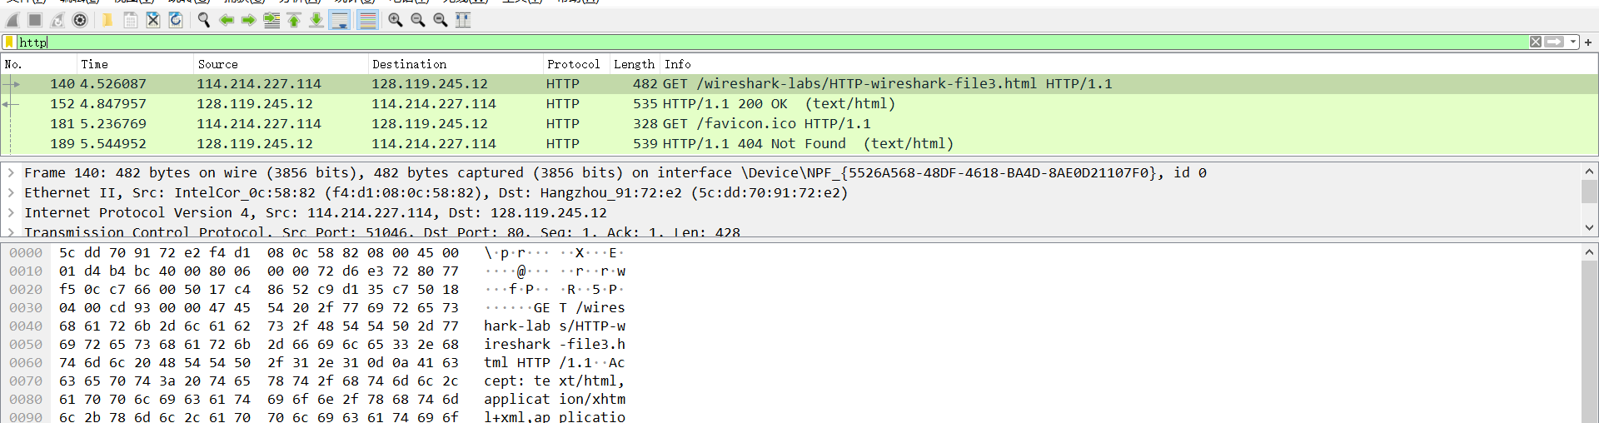
（4）HTML Documents with Embedded Objects
清空浏览器缓存，打开wireshark进行捕获报文，并打开第四个网页：
http://gaia.cs.umass.edu/wireshark-labs/HTTP-wireshark-file4.html
等到两张图片都加载完之后停止捕获，得到下图所示报文：

（5）HTTP Authentication
清空浏览器，打开wireshark开始捕获。并打开第五个网页：
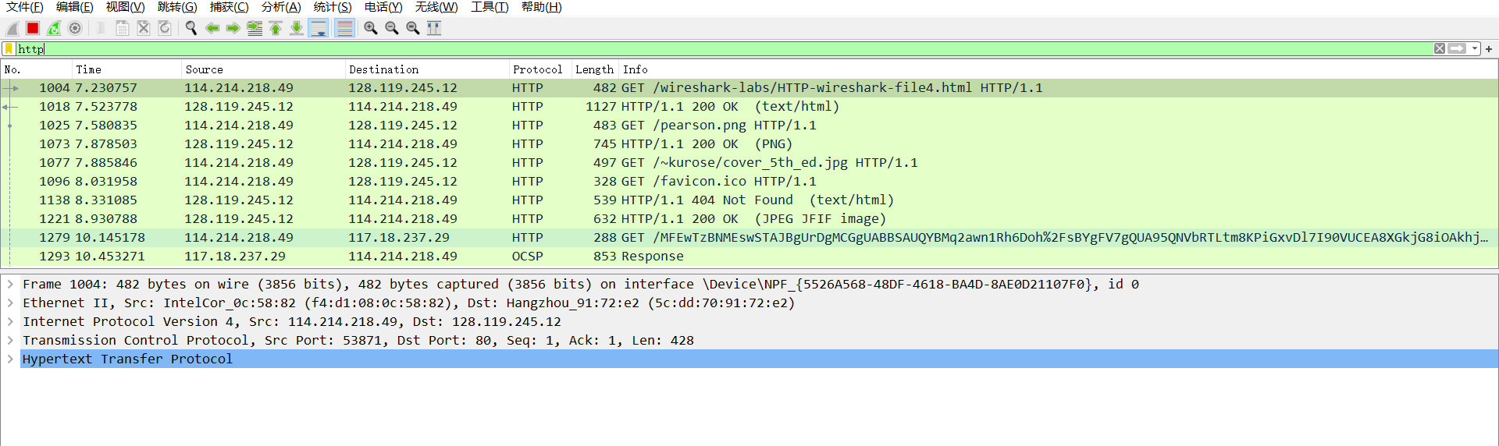
http://gaia.cs.umass.edu/wireshark-labs/protected_pages/HTTP-wireshark-
file5.html
并输入实验介绍中给出的账号和密码，等到页面加载完毕后，停止捕获，得到如下图所示的报文：
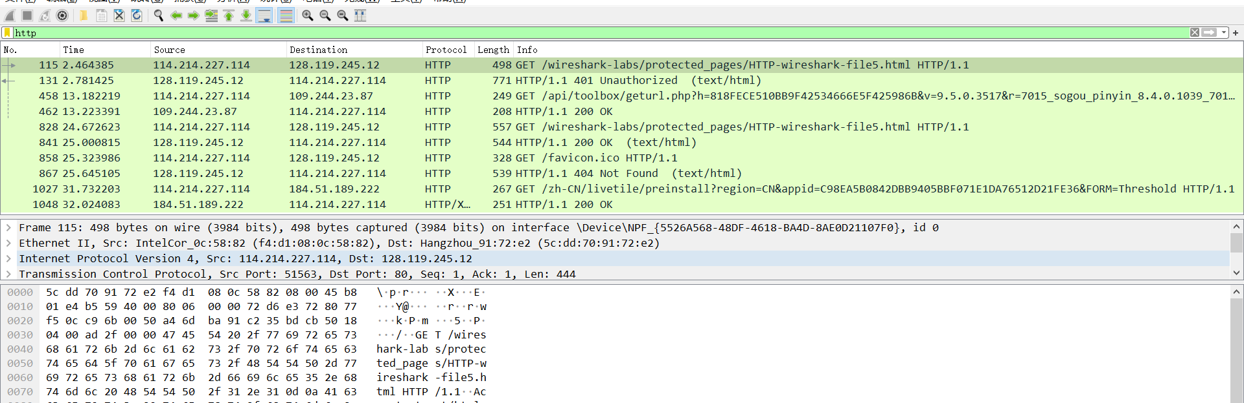

五、 结果分析
1．关于五次http报文抓取的分析
（1）Is your browser running HTTP version 1.0 or 1.1? What version of HTTP is the server running?
都是HTTP/1.1
(2) What languages (if any) does your browser indicate that it can accept to the
server?
简体中文（大陆使用），简体中文
（3）What is the IP address of your computer? Of the gaia.cs.umass.edu server?
我的是114.214.227.114；服务器的是128.119.245.12
（4）What is the status code returned from the server to your browser?
（5）When was the HTML file that you are retrieving last modified at the server?
（6）How many bytes of content are being returned to your browser?
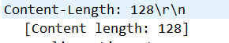
（7）By inspecting the raw data in the packet content window, do you see any headers
within the data that are not displayed in the packet-listing window? If so, name
one.
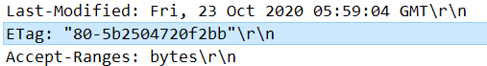
例如：Last-Modified.
(8) Inspect the contents of the first HTTP GET request from your browser to the
server. Do you see an “IF-MODIFIED-SINCE” line in the HTTP GET?
没有看见。
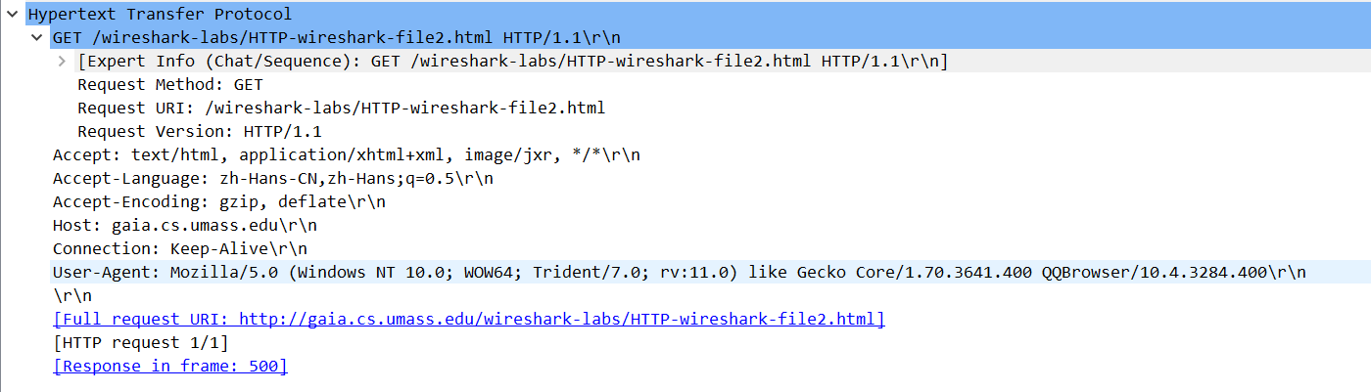
（9）Inspect the contents of the server response. Did the server explicitly return the
contents of the file? How can you tell?
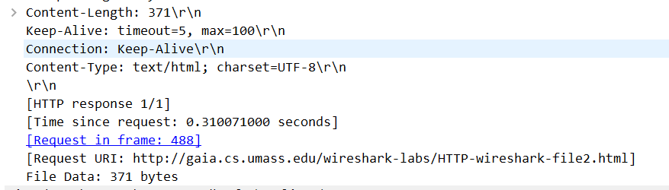
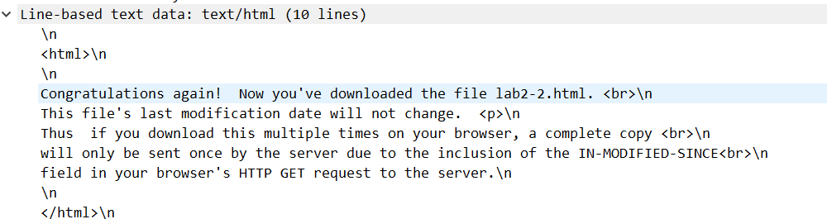
返回了文件内容。因为此报文中包含了文件内容的一些信息
（10）Now inspect the contents of the second HTTP GET request from your browser to
the server. Do you see an “IF-MODIFIED-SINCE:” line in the HTTP GET? If
so, what information follows the “IF-MODIFIED-SINCE:” header?
跟随着Last-Modified对应的时间：
（11）What is the HTTP status code and phrase returned from the server in response to
this second HTTP GET? Did the server explicitly return the contents of the file?
Explain.
是304 Not Modified.没有显式地传一个文件的内容，因此此次报文并没有包含任何有关文件的信息
（12）How many HTTP GET request messages were sent by your browser?
1个
（13）How many data-containing TCP segments were needed to carry the single HTTP
response?
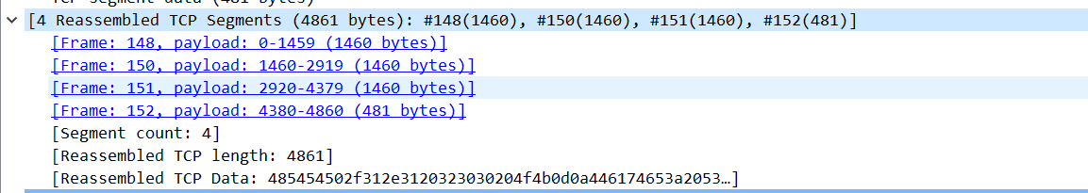
4个
（14）What is the status code and phrase associated with the response to the HTTP GET
request?
（15）Are there any HTTP status lines in the transmitted data associated with a TCP-
induced “Continuation”?
没有。在第三部分的pdf的介绍中明确的说明过此问题。
（16）How many HTTP GET request messages were sent by your browser? To which
Internet addresses were these GET requests sent?
一共有五个。可以参见实验内容第四部分中给出的报文截图。
4个发往128.119.245.12,1个发往117.18.237.29
（17）Can you tell whether your browser downloaded the two images serially, or
whether they were downloaded from the two web sites in parallel? Explain.
serially.因为发出了第一张图之后，等到了响应之后发出的第二张图片。
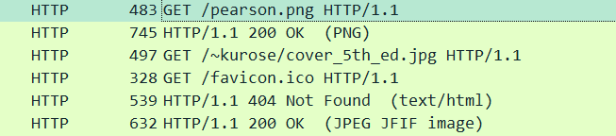
（18）What is the server’s response (status code and phrase) in response to the initial
HTTP GET message from your browser?
（19）When your browser’s sends the HTTP GET message for the second time, what
new field is included in the HTTP GET message?
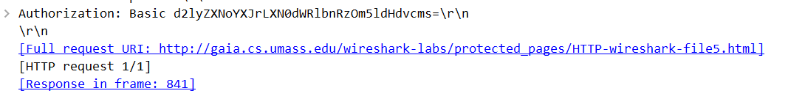

2.ppt中的问题
分析HTTP中get和post请求方式的区别：
答：1.get是不安全的，因为在传输过程中，数据被放在了请求的URL中；post的所有操作对用户来说都是不可见的
2.get传送的数据量较小，这主要是因为受URL长度的限制；post传送的数据量较大，一般被默认为不受限制
3.get是从服务器上获取数据的，post是向服务器传送数据的

3.<<Wireshark简介>>对应的问题的回答：
1. List up to 10 different protocols that appear in the protocol column in the
unfiltered packet-listing window in step 7 above.
ARP,TCP,ICMP,OICQ,DNS,DHCP,SSDP,MDNS,LLMNR,TCP

2. How long did it take from when the HTTP GET message was sent until the HTTP
OK reply was received? (By default, the value of the Time column in the packet-
listing window is the amount of time, in seconds, since Wireshark tracing began.
To display the Time field in time-of-day format, select the Wireshark View pull
down menu, then select Time Display Format, then select Time-of-day.)
0.25s
3. What is the Internet address of the gaia.cs.umass.edu (also known as www-
net.cs.umass.edu)? What is the Internet address of your computer?
128.119.245.12 114.214.222.31(本地)

4.第一条：
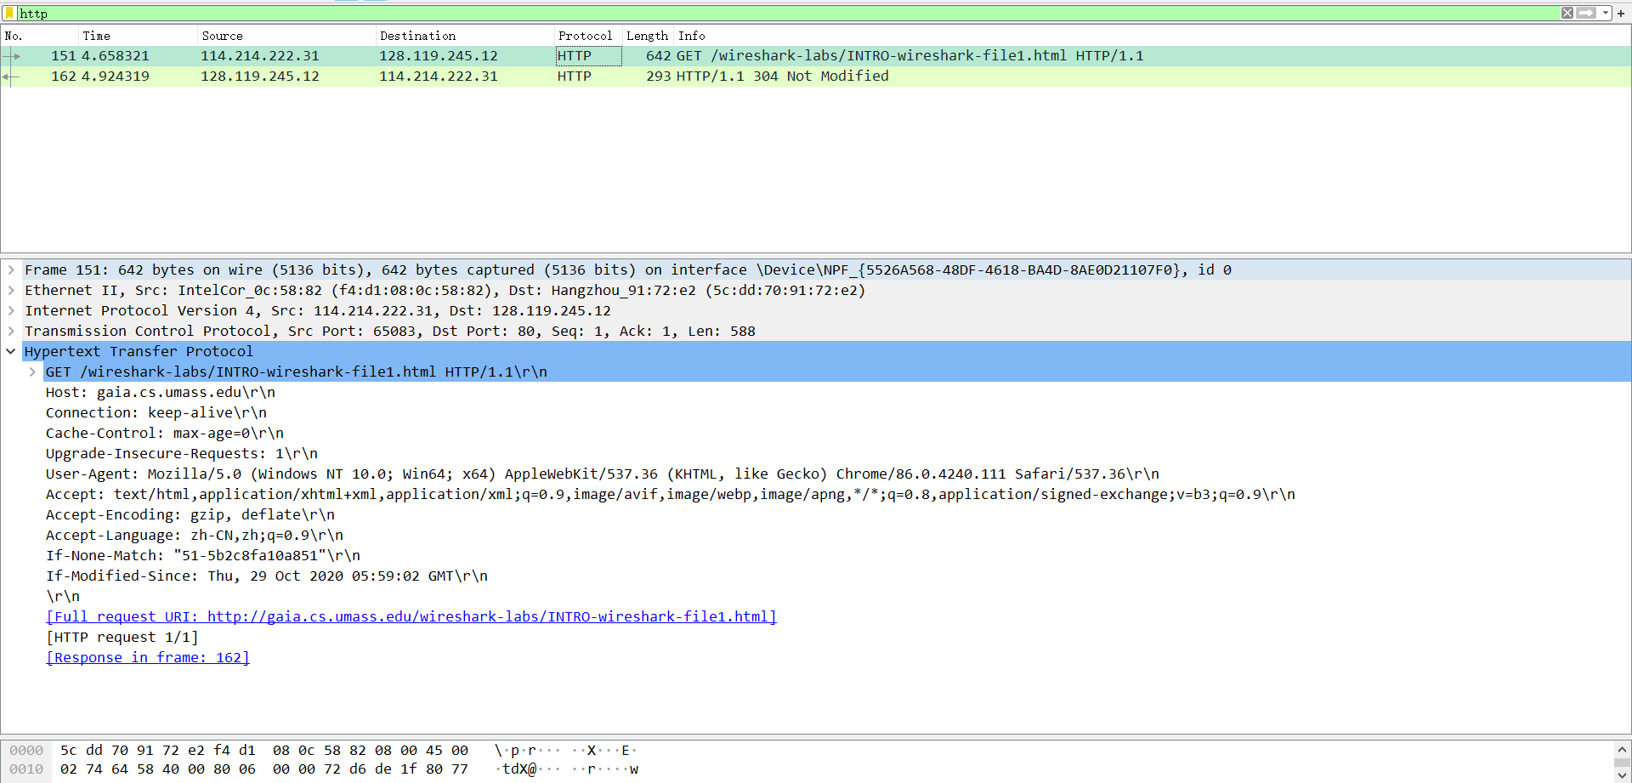

第二条：
